## Actions

Actions helps testers to divide scripts into groups of QTP statements called actions. Actions are similar to functions in VBScript, however there are few differences. By Default QTP creates a test with 1 action.

## Types of Actions:

There are three types of actions:

* **Non-reusable action** - An action that can be called only in that specific test in which it has been designed and can be called only once
* **Reusable action** - An action that can be called multiple times any test in which it resides and can also be used by any other tests
* **External Reusable action** - It is a reusable action stored in another test. External actions are read-only in the calling test, but it can be used locally with the editable copy of the Data Table information for the external action

## Working with Actions:

There are three options to insert an action. Click on each one of those to know more about the selected type of action.

|  |  |
| --- | --- |
| **Action Type** |  |
| [**Insert Call to New Action**](http://www.tutorialspoint.com/qtp/qtp_call_to_action.htm) | Inserts a New Action from the existing action |
| [**Insert Call to Copy of Action**](http://www.tutorialspoint.com/qtp/qtp_call_to_copy_of_action.htm) | Inserts a copy of an existing action |
| [**Insert Call to Existing Action**](http://www.tutorialspoint.com/qtp/qtp_call_to_existing_action.htm) | Inserts a call to existing re-usable action |

## Inserting Call to New Action:

Testers can insert a new action at any point of the script by performing the following steps:

**Step: 1** - Right Click on the Scripting area and select "Call to New Action"

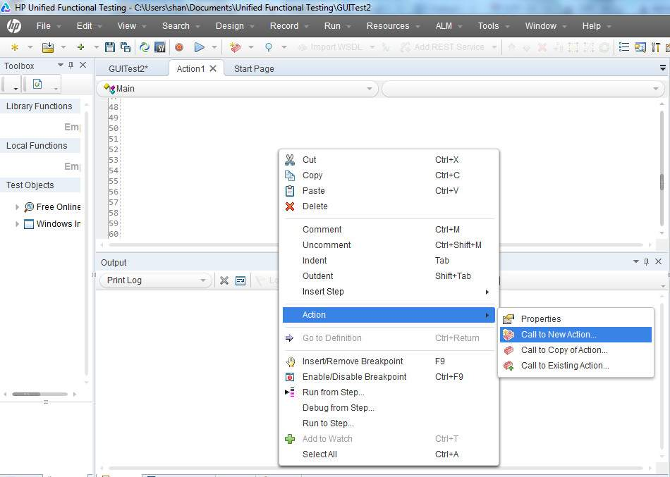

**Step: 2** - In the "Insert Call to New Action" Window, give the test name, description, and also specify if it is a reusuable action or not. Most Importantly select the location the action to be inserted.

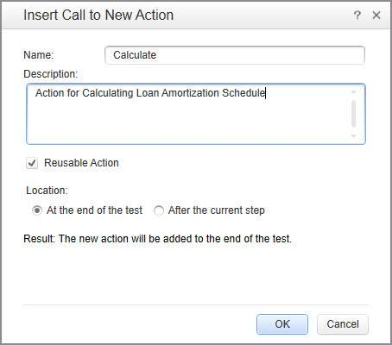

**Step: 3** - User Can check the changes graphically in the test Name Tab as shown below:

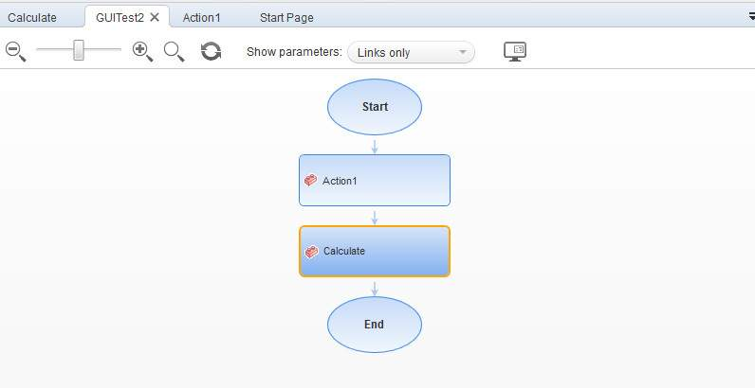

We can also use QTP commands to call the Action at any point in the script.

RunAction "Calculate", oneIteration 'Executes Calculate Action for one iteration.

Action can be called with Parameters as shown below:

'Input to the action

num1 = 5

num2 = 10

Dim value1

'Run the action with parameters

OutputValue = RunAction("Calculate", oneIteration, num1, num2, value1)

'Display the output

print OutputValue

## Inserting Call to Copy of Action:

Testers can insert a copy of an existing action at any point of the script by performing the following steps:

**Step : 1** - Right Click on the Scripting area and select "Call to Copy of Action"

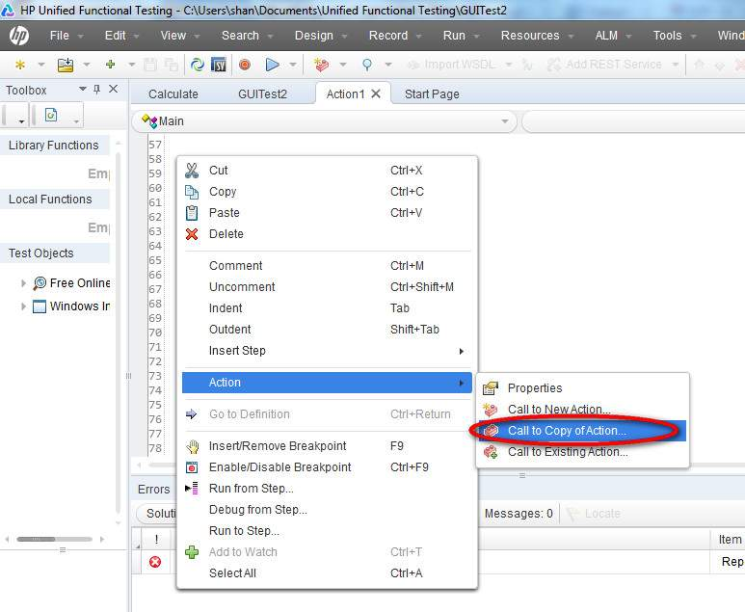

**Step : 2** - In the "Insert Call to Copy of Action" Window, Select the "Test Name", "Action Name" and also select the location the action to be inserted.

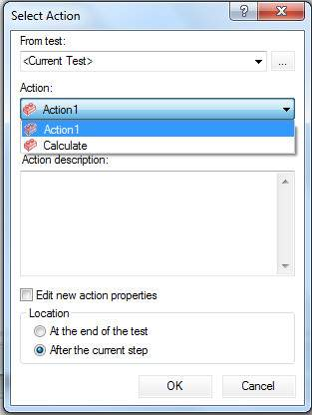

**Step : 3** - Immediately script is autogenerated to show that the copy of an action is inserted.

RunAction "Copy of Calculate", oneIteration

**Step : 4** - User Can check the changes graphically in the test Name Tab as shown below:

## Inserting Call to Copy Action Step 3

## Inserting Call to Existing Action:

Testers can insert an Existing action at any point of the script by performing the following steps:

**Step : 1** - Right Click on the Scripting area and select "Call to Existing Action"

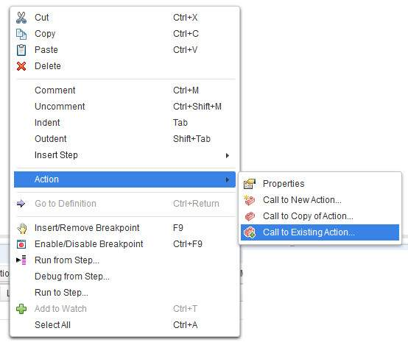

**Step : 2** - In the "Select Action" Window, give the test name, Action name, description and also specify the location of the action to be inserted.

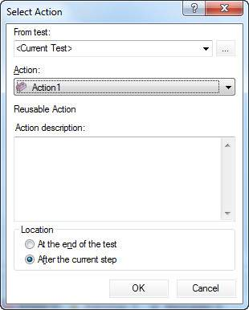

**Step : 3** - Once inserted, the below script is generated exactly in the location where the action was inserted.

RunAction "Action1", oneIteration

**Step : 4** - User Can check the changes graphically in the test Name Tab as shown below:

